SNAPSHOT IOWA
Contest Entry Form

Please tape this form to the back of the photo(s).
Who: All Iowa students, grades 7th-12th are eligible, including home-schooled students.
What: Unmounted, black and white PHOTOGRAPHS SHOWCASING IOWA ARCHITECTURE!
When: Entries must be received by Friday, February 3rd, 2017
Why: One winner from each group will be featured on our website AND earn a $100 cash prize: 7th-9th Grades and 10th – 12th Grades.
NEW THIS YEAR: Winners will ALSO get their art featured at their local library, and on the Iowa Library Association social media at https://www.facebook.com/IowaLibAssoc/.

HEADLINE: Where in Iowa do YOU like to read?

_____________________________________________________________________________

Student’s name, grade, age, signature and full home mailing address.

_____________________________________________________________________________

_____________________________________________________________________________

_____________________________________________________________________________

_____________________________________________________________________________

Parent or legal guardian’s name, signature and contact information (phone and/or e-mail).

_____________________________________________________________________________

Student’s school name and city

_____________________________________________________________________________

Title and description (100 words or less) explaining why the subject of the photography was selected. Include the name and location of the subject.
__________________________________________________________________________
__________________________________________________________________________
__________________________________________________________________________
__________________________________________________________________________
__________________________________________________________________________
Each student may submit up to three photographs. The student must take the photo, no group work allowed.
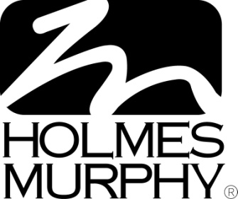
Mail photo(s) between two sheets of corrugated cardboard or like material to prevent damage in the mail. The IAF reserves the right to exclude damaged entries • Contact information (phone numbers/e-mail addresses) will not be released to the public, but press releases with students’ name and school will go out if they win • If selected as a winner, a jpg file of the photo (high resolution) may be requested via e-mail • All information must be legible for the entry to be valid • No response to prize notification within five days will forfeit the prize • Photography of private residences must provide proof of owner’s permission to photograph the home • Entry images become the property of the IAF • Winners will be announced after March 3rd, 2017. FOR ENTRY FORMS AND MORE INFORMATION VISIT www.iowaarchfoundation.org. Prize money donated by:

